**Solution Of Assignment-5(ML)**

import pandas as pd

data = {'Date': ['10–01–16', '10–02–16', '10–03–16', '10–04–16', '10–05–16', '10–06–16', '10–07–16'],

        'Open': [770.25, 776.030029, 774.25, 776.030029, 779.3541998, 776.306698, 779.659973],

        'High': [776.075902, 778.730022, 776.065702, 771.710022, 782.073407, 782.46398, 7],

        'Low': [769.5, 780.890015, 766.5, 772.890015, 775.650024, 775.539978, None],

        'Close': [782.659998, 776.429993, 772.549798, 776.429993, 776.469971, 776.859985, None]}

df = pd.DataFrame(data)

print(df)

Date Open High Low Close

0 10–01–16 770.250000 776.075902 769.500000 782.659998

1 10–02–16 776.030029 778.730022 780.890015 776.429993

2 10–03–16 774.250000 776.065702 766.500000 772.549798

3 10–04–16 776.030029 771.710022 772.890015 776.429993

4 10–05–16 779.354200 782.073407 775.650024 776.469971

5 10–06–16 776.306698 782.463980 775.539978 776.859985

6 10–07–16 779.659973 7.000000 NaN NaN

#1

import matplotlib.pyplot as plt

# a) Line Chart

plt.figure(figsize=(5, 3))

plt.plot(df['Date'], df['Open'], label='Open', color='blue')

plt.plot(df['Date'], df['High'], label='High', color='green')

plt.plot(df['Date'], df['Low'], label='Low', color='red')

plt.plot(df['Date'], df['Close'], label='Close', color='purple')

plt.xlabel('Date')

plt.ylabel('Price')

plt.title('Stock Prices Over Time')

plt.legend()

plt.show()

# b) Bar Graph

plt.figure(figsize=(5, 3))

plt.bar(df['Date'], df['Close'], label='Close', color='orange')

plt.xlabel('Date')

plt.ylabel('Closing Price')

plt.title('Closing Stock Prices')

plt.legend()

plt.show()

# c) Histogram - Assuming we want to see distribution of closing prices

plt.figure(figsize=(5, 3))

plt.hist(df['Close'], bins=5, label='Close', color='gray', edgecolor='black')

plt.xlabel('Closing Price')

plt.ylabel('Frequency')

plt.title('Distribution of Closing Prices')

plt.legend()

plt.show()

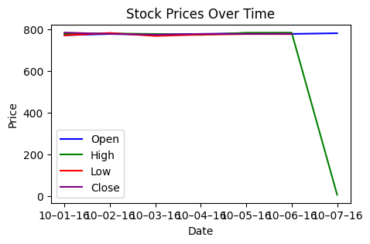 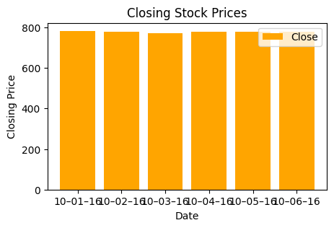

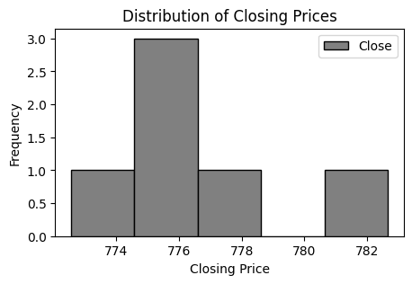

#2

import matplotlib.pyplot as plt

plt.figure(figsize=(5, 3))

for column in df.columns[1:]:  # Iterate over columns except 'Date'

    plt.plot(df['Date'], df[column], label=column)

plt.xlabel('Date')

plt.ylabel('Value')

plt.title('Multiline Plot of Stock Data')

plt.legend()

plt.show()

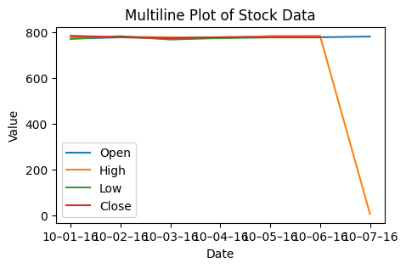

#3

df.plot.scatter(x='Date', y='Open', color='red')

plt.title('Scatter Plot - Open Values')

plt.xlabel('Date')

plt.ylabel('Open Value')

plt.show()

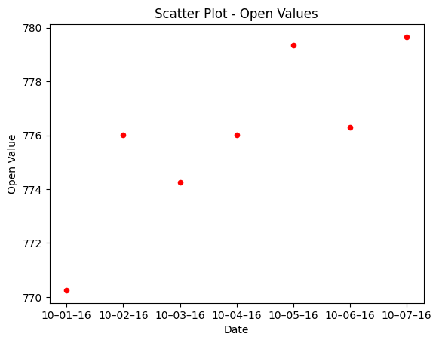

#4

df.plot(x='Date', y=['Open', 'Close'], kind='bar', color=['blue', 'green'])

plt.title('Bar Chart - Open and Close Values')

plt.xlabel('Date')

plt.ylabel('Value')

plt.legend(['Open', 'Close'], loc='best')

plt.show()

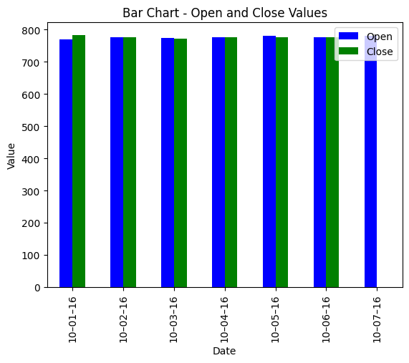

#5

df.plot(x='Date', y=['High', 'Low'], kind='bar', color=['purple', 'orange'])

plt.title('Bar Chart - High and Low Values')

plt.xlabel('Date')

plt.ylabel('Value')

plt.legend(['High', 'Low'], loc='best')

plt.show()

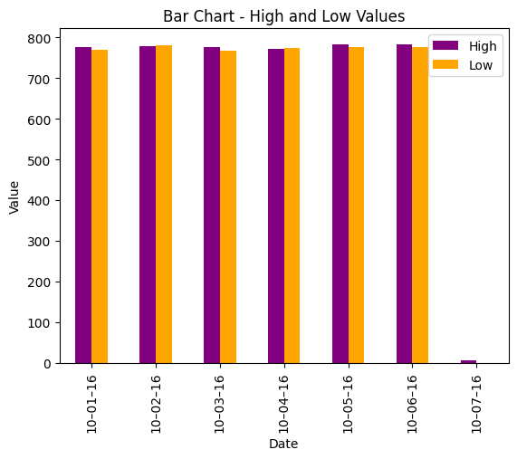

#6.a) Histogram

df['Close'].plot(kind='hist', bins=10, color='grey')

plt.title('Histogram - Close Values')

plt.xlabel('Close Value')

plt.ylabel('Frequency')

plt.show()

#b) Bar Chart

df['Close'].value_counts().plot(kind='bar', color='cyan')

plt.title('Bar Chart - Close Values')

plt.xlabel('Close Value')

plt.ylabel('Frequency')

plt.show()

#c) Pie Chart

df['Close'].value_counts().plot(kind='pie', autopct='%1.1f%%')

plt.title('Pie Chart - Close Values')

plt.show()

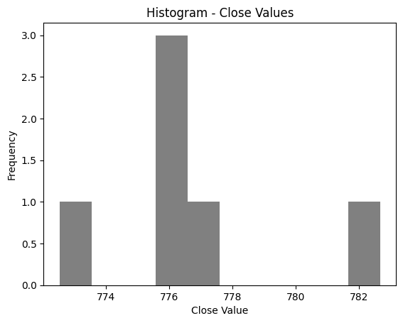 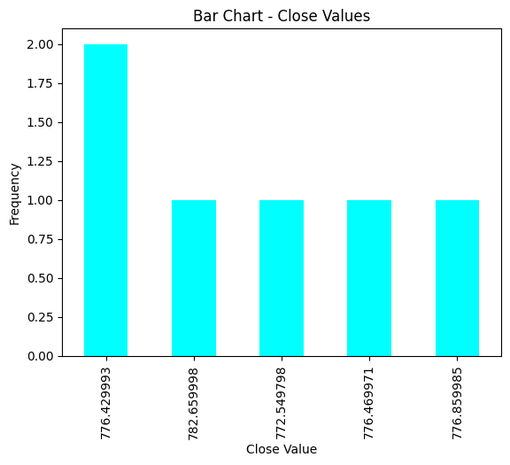

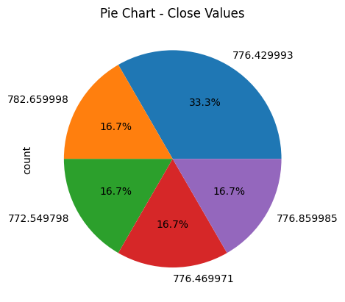

#7

df['Open'].value_counts().plot(kind='pie', autopct='%1.1f%%', colors=['red', 'blue', 'green', 'orange', 'purple'])

plt.title('Pie Chart - Open Values')

plt.show()

